

**Education and Children’s Services**

**QUALITY IMPROVEMENT VISIT REPORT**

**Johnshaven School**

**11th September 2017**

|  |  |
| --- | --- |
| **Dates of visit** | **11th September 2017** |
| **QIV Team:** | **Kay MacDonald QIO** |
|  | **Deborah Masson QIO** |
|  |  |
|  |  |
|  |  |
|  |  |
| **Report prepared by:** | **Kay MacDonald** |

|  |
| --- |
| **Introduction** |

The purpose of a Quality Improvement Visit is to support and challenge the school with improving experiences for children and young people leading to raised attainment and opportunities for achieving the skills they will need for, learning, life and work. In the course of the visit, the extent to which the school’s self-evaluations can be validated in relation to the four core quality indicators will be considered. Themes identified by Education Scotland and Aberdeenshire for the current session, and the key drivers for improvement as identified in the National Improvement Framework, will be explored.

As part of the visit aspects where improvement would lead to more secure and increased evaluations will be suggested. These aspects for improvement need to be kept in perspective and considered in the context of the strengths of the school, which will be identified during the visit.

The focus of the visit is divided into three categories:

* **Leadership and Management:** How good is our leadership and approach to improvement?
* **Learning Provision:** How good is the quality of care and education we offer?
* 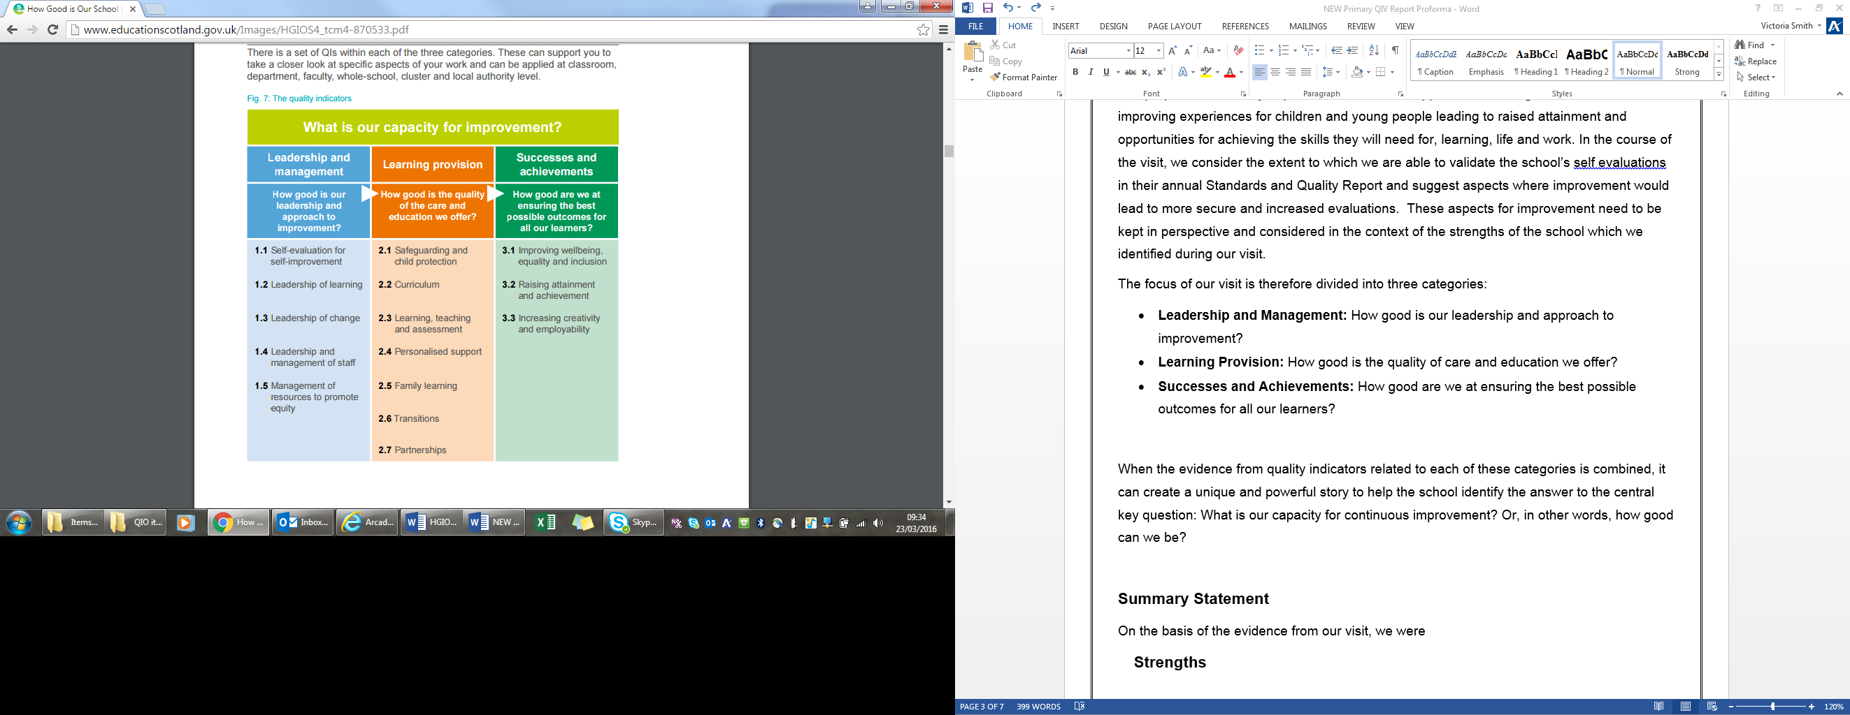**Successes and Achievements:** How good are we at ensuring the best possible outcomes for all our learners?

The report will focus on the core quality indicators, but will also reflect aspects of related themes.

When the evidence from quality indicators linked to each of these categories is combined, it can create a unique and powerful story to help the school identify the answer to the central key question:

What is our capacity for continuous improvement? Or, in other words, how good can we be?

(HGIOS 4 Page 15)

**Summary Statement**

A Quality Improvement visit took place at Johnshaven School on Monday 11th of September. This visit was conducted in order to support the school moving forward with almost an entirely new staff team in place. The purpose of the visit was to identify strengths and areas for improvement going forward in line with the school’s own self-evaluation processes. The visit included dialogue with all stakeholders and classroom observations of learning and teaching. From this visit there is a clear sense of the capacity to improve all areas of Johnshaven School and an emerging picture of all stakeholders working positively towards a common purpose.

On the basis of the evidence from the visit, the following was identified:

**Strengths**

* The very positive start made by the newly appointed Head Teacher in all areas of school improvement.
* The effective partnership working emerging across the school community to the benefit of all.
* The positive ethos developing at Johnshaven School and clear evidence of collegiate working amongst all staff.
* The calm, positive environment for learning that is developing across the school.

**Aspects for Improvement**

* Develop an appropriate curriculum rationale to ensure children have suitable opportunities to learn and achieve at Johnshaven School.
* Continue to develop approaches to learning and teaching to ensure consistent high quality experiences for all pupils.
* Continue to develop effective assessment practices focussing on AIFL strategies including effective feedback and identification of next steps.
* Continue to build up effective self-evaluation practices in order to ensure continuous improvement for all at Johnshaven School.

|  |
| --- |
| **1. How good is our leadership and approach to improvement?** |

QIs which relate to NIF key drivers for this question – 1.1, 1.2. 1.3

**N.I.F. key driver(s) for Improvement:**

* **School leadership**
* **Assessment of Children’s progress**

**QI 1.3 Leadership of Change**

On the basis of the evidence from the visit, the following was identified:

Strengths

* The Head Teacher has made a very positive start to the leadership of change in Johnshaven School. She has a clear agenda of the improvement agenda for the school going forward. It is clear that she has built up some very positive relationships with staff, pupils and parents.
* The school have clearly considered the vision, values and aims for Johnshaven and work has begun embedding this into the everyday working practices of the school.
* All staff at Johnshaven are developing a clear focus on improving outcomes for learners and there is evidence of staff reviewing practice in order to consider/develop areas for improvement.
* The school have made a positive start to developing effective links with both parents and a number of different groups in the community. The Head Teacher has been very proactive in seeking out community links in Johnshaven.
* Effective lines of communication are being developed with parents and initial feedback is showing that this is very much valued.

**Aspects for Improvement**.

* Continue work on Vision, values and aims in order to embed these in the life and work of the school including work planned with pupils on exemplification.
* Utilise How Good is our School 4 to support effective, focussed self-evaluation activities throughout the session with all stakeholders.
* Develop a curriculum rationale which is relevant to Johnshaven School.
* Continue the very positive start made to building effective relationships with all in Johnshaven community through both face to face events as well as other methods of communication.
* Build opportunities to share pupil’s learning with parents/carers.

|  |
| --- |
| **2. How good is the quality of care and education we offer?** |

**N.I.F. key driver(s) for Improvement:**

QIs which relate to NIF key drivers for this question –

2.2; 2.3; 2.4; 2.5; 2.6; 2.7

* **Teacher Professionalism**
* **Parental Engagement**
* **Assessment of Children’s Progress**
* **School Improvement**

**QI 2.3 Learning, teaching and assessment**

On the basis of the evidence from the visit, the following was identified:

**Strengths**

* The ethos developing across the school is positive. Learners are respectful and behaviour is good. There is a calm and purposeful environment for learning developing.
* Staff have started to utilise Aberdeenshire Frameworks and National benchmarks to support effective planning and ensure learning experiences match pupils’ needs.
* School staff are planning to engage effectively with appropriate literature to support the development of effective and consistent approaches to learning and teaching.

**Aspects for Improvement**

* Continue with the work noted above regarding the use of literature and cluster work around Visible Learning to support the development of a consistent approach to effective learning and teaching which allows for differentiation, skilled questioning and ensures that pace and challenge is appropriate for all learners.
* Continue to develop the appropriate use of learning intentions and Success Criteria in order to ensure pupils are actively engaged in their learning and can review progress/identify next steps.
* Develop approaches to allow pupils to take more responsibility and enable them to discuss their learning and how they can improve on it/identify their next steps. This could look to include the development of effective processes for pupils to share their learning appropriately with their parents/carers.

|  |
| --- |
| **3. How good are we at improving outcomes for all our learners?** |

QIs which relate to NIF key drivers for this question –

3.2; 3.3

**N.I.F. key driver(s) for Improvement:**

* **School Improvement**
* **Performance Information**

**QI 3.2 Raising attainment and achievement**

On the basis of the evidence from the visit, the following was identified:

**Strengths**

* The school have developed a system to allow pupils to share their achievements both in and outside school and these achievements are celebrated weekly. Initial feedback on this has been positive.
* The Head Teacher can articulate the school performance data to date, identifying current strengths and areas for development. Areas for development have been incorporated into the school improvement plan.
* Staff have begun to plan using appropriate Frameworks and Benchmarks which will lead to increased confidence in the accuracy of professional judgements made.

**Aspects for improvement**

* Ensure standardised data and professional judgement are used effectively to track and monitor pupil progress and attainment.
* Continue to develop effective tracking and monitoring processes and procedures to allow the school to effectively track pupil progress throughout the school session.
* Develop systems to effectively track pupils’ wider achievements both in and outside school
* Engage in moderation activities both in school and across the cluster to develop the validity of judgements made in line with national advice.

**QI 3.1 Improving wellbeing, equality and inclusion**

On the basis of the evidence from the visit, the following was identified:

Strengths

* All staff are positive in their interactions with pupils and are working hard to promote an environment where all will feel safe, secure and valued.
* Staff have all received appropriate training in Child protection procedures.
* The school has begun to raise awareness of the *UN Convention on the Rights of the Child* (UNCRC) amongst children, and staff.
* The Head Teacher has reviewed all pupils who receive additional support with staff and as a result the deployment of staff/resources is more closely aligned to pupil need.

**Aspects for improvement**.

* Develop clear staged intervention processes to support pupils effectively.
* Develop effective processes to plan review and track the impact of interventions implemented to support pupils with Additional Support Needs including the use of IEPs.
* Continue with the positive start made to developing the understanding of GIRFEC principles and practice with all stakeholders.

|  |
| --- |
| **4. Next steps to support improvement.** |

**Actions for the school**

**Actions for the Quality Improvement Officer**

**Actions for other Officers**

**Aberdeenshire Council – Education and Children’s Services: Quality Improvement Visit Action Plan**

|  |  |  |  |
| --- | --- | --- | --- |
| **School:** |  | **Date plan completed:** |  |
| **Head Teacher:** |  | **Date plan started:** |  |

|  |  |  |  |  |  |
| --- | --- | --- | --- | --- | --- |
| **Action** | **Individual**  **responsible** | **Target**  **completion date** | **Evidence/Performance measures** | **Review date(s)** | **Additional Supports (if required)** e.g. officer support, additional training etc. |
|  |  |  |  |  |  |
|  |  |  |  |  |  |
|  |  |  |  |  |  |
|  |  |  |  |  |  |
|  |  |  |  |  |  |