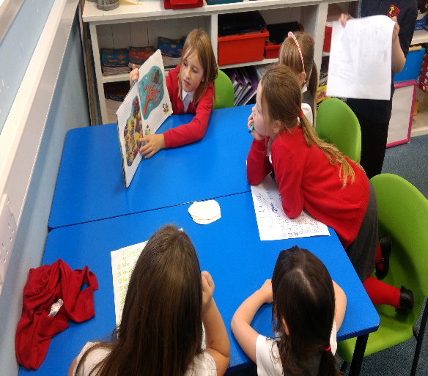
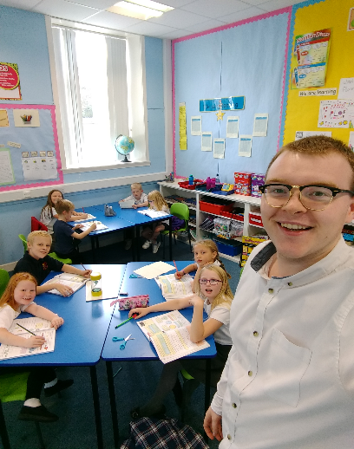

Positive Behaviour Management Policy
Johnshaven School
Johnshaven School takes the behaviour and manners of pupils seriously, not only as a commitment to improving learning experiences, but also as skills for work and life. The Forbes Magazine, Career Attraction and Undercover Recruiter rank friendliness in their top ten traits employers seek in new employees. Therefore, instilling good manners and a caring disposition in our pupils are a priority not just for life but also for work. This will be done in a number of ways depending on the nature of the situation taking place at school.
Restorative Justice
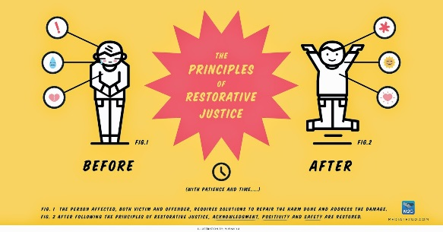
A restorative school is one which takes a restorative approach to resolving conflict and preventing harm.
Restorative approaches enable those who have been harmed to convey the impact of the harm to those responsible, and for those responsible to acknowledge this impact and take steps to put it right.
It involves key questions, such as
- “What happened?”
- “What were you feeling when this took place?”
- “What were you thinking when this took place?”
- “Who else has been affected by the incident?”
- “How can we fix this?”
This involves critical thinking and problem solving on the child’ part, empowering them to put things right in the future and allowing them to explore in-depth the consequences of below-standard behaviour. Pupils are encouraged to think of their own meaningful approach to repairing their relationship, allowing all parties to move on from hurt feelings and disputes.
Restorative approaches refer to a range of methods and strategies which can be used both to prevent relationship-damaging incidents from happening and to resolve them if and when they take place.
(Taken from https://restorativejustice.org.uk/restorative-practice-schools)
Taken from ‘The Use and Effectiveness of Anti-Bullying Strategies in Schools’
Dept. for Education, 2010

Pupils involved in conflict at Johnshaven School are encouraged and supported through a process of Restorative Practice, an approach which encourages all sides of a dispute to reflect verbally on their thoughts and feelings which they experienced throughout an incident. This allows pupils to empathise with all parties involved and lead to a more open approach to resolving an issue. Pupils will then be encouraged to co-create a method of fixing or ‘restoring’ the relationship between pupils. Restorative practice will be used as the conflict management tool and all staff will take this approach when dealing with disputes in the playground, and in class.
Restorative Justice consists of 5 steps:
- Talking about the problem: WHAT happened?
- Thoughts at the time: WHAT were you thinking while this was happening?
- Feelings at the time: HOW did the incident make you feel?
- Considering the damage: WHO else was affected by what happened?
- Repairing the relationship: HOW can we fix this together?

Why is this the right approach?
The Curriculum for Excellence section of ‘Skills for Learning Life and Work’ identifies developing thinking skills as a tool which goes beyond literacy. These skills can be pare down to:
- Remembering involves such activities as recall, recognition or locating information
- Understanding might involve activities such as describing, explaining, summarising and translating
- Applying requires the learner to use or apply their knowledge and understanding in different contexts
- Analysing requires learners to break down information into component parts and search for relationships
- Evaluating involves making an informed judgement about something, for example an issue or method. Activities such as comparing, appraising, prioritising, rating or selecting, could involve learners in evaluating
- Creating happens when learners are required to generate new ideas and products through activities such as designing, creative writing, planning, reconstructing, inventing, formulating, producing and composing

Following the programme of Restorative Justice allows pupils to solve conflicts in a way which allows them to practice REMEMBERING an incident, UNDERSTANDING why tensions have become high, EVALUATE the impact that this has had on another person, and CREATING a solution which will restore their relationship. Not only has this approach proven to be successful in a variety of school, it also allows pupils an opportunity to use and develop their own thinking skills to solve relationship problems. This will strengthen social problem solving skills, allowing pupils more opportunities to become SUCCESSFUL LEARNERS.

ClassDojo

ClassDojo is a simple and exciting tool which allows teachers and parents to keep in touch about behaviour, administration, and to celebrate achievement in and out of school. The gain or loss ‘Dojo points’ in school can be tracked by parents and carers using the ClassDojo app and signing in via your child’s generated code.
At the beginning of each term, pupils will discuss, negotiate and co-create a reward chart regarding ClassDojo, which will consist of rewards given for members of the class attaining certain numbers of points.
A separate chart will be created to allow rewards for a class collectively receiving a certain number of points, allowing pupils to become RESPONSIBLE CITIZENS of their own classroom community.
20 | Change your Mojo character
40 | 10 mins extra Golden Time
60 | Dress as you please afternoon
75 | Games Hour
100 | Watch a movie
125 | Half Work, Half Golden Time afternoon
150 | Pyjama Day
200 | Individual Gift (first person gets a party)

Example of ClassDojo reward chart.

If pupils receive 50 Dojo points, they will gain a certificate to recognise their achievement and this will be shared with parents.
In the event of achieving 50 Class Dojo points, pupils will always receive a certificate to take home in recognition of their achievement.
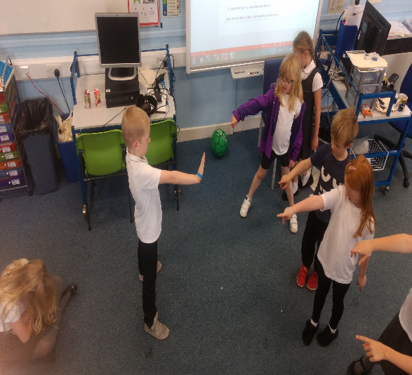

BULLYING
Bullying may be defined as a range of pre-meditated, persistent and often deliberate actions, undertaken by a person or a group of people, which cause the victim(s) physical or emotional distress.
It may be useful at this point to draw a distinction between acts of bullying and incidents which, although not to be encouraged, are commonplace when groups of children play together. An occasional tussle or quarrel between two children will be treated as a breach of discipline by staff, but it is not bullying. Similarly, reciprocal or casual name-calling is not to be condoned, but it is not bullying. Sustained victimisation is. The crucial distinction is where the imbalance of power is such that the victim clearly needs positive support. At the same time the bully needs to be made aware of the damage, which his/her actions are causing.
The school is opposed to all forms of bullying behaviour, be this physical, verbal, threatening and intimidating behaviour or ostracism from groups, games or activities, and we will do everything in our power to prevent such behaviour amongst our pupils, and to deal effectively with any incidents which might occur. Victims of bullying are supported by a range of strategies and resources depending upon the needs of the child and the nature of the incidents. However, please be reassured that incidents of bullying in Johnshaven School are few and far between.
We believe that a strong, positive school ethos and constant work on building a caring school community, together with close contact with parents, offer the best way forward.

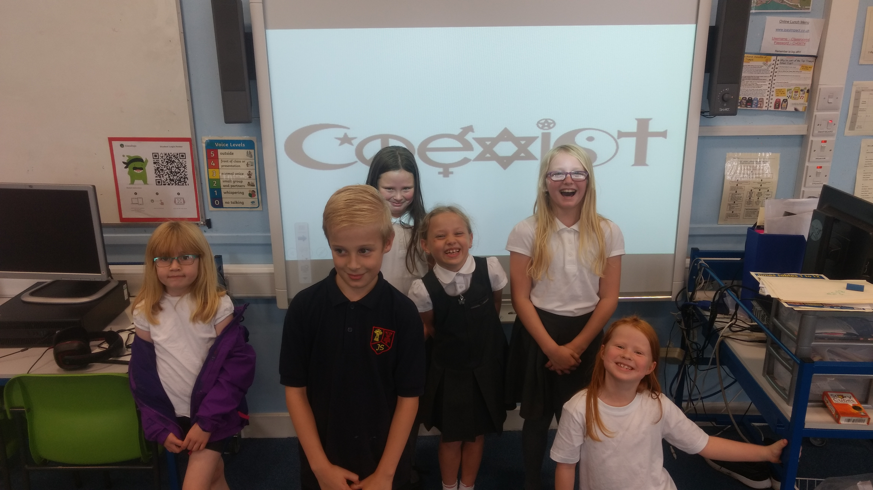

Rights Respecting School
Johnshaven School is currently striving to become a Rights Respecting School, meaning it respects the findings of the United Nations Convention on the Rights of the Child, which found that certain rights should be adhered to if children were to have a happy and successful life.
Most important of these to us as a school are as follows:
- Article 12 - You have the right to give your opinion and for adults to listen and take it seriously.
- Article 13 - You have the right to find things out and share what you think with others, by talking, drawing and writing, or in any other way unless it harms or offends other people.
- Article 15 - You have the right to choose your own friends and to join or set up groups as long as it isn’t harmful to others.
- Article 19 - You have the right to be protected from being hurt and mistreated, in body and mind.
- Article 24 - You have the right to the best health care possible, safe water to drink, nutritious food, a clean and safe environment and information to help you stay well.
- Article 28 - You have the right to a good quality education. You should be encouraged to go to school to the highest level you can.
- Article 31 - You have the right to play and rest.
Children will be encouraged to familiarise themselves with these rights. We hope that the children will see this as a responsibility to behave in such a way that ensures all children’s rights are respected. Pupils who behave in such a way which violates the rights of their peers will have their attention drawn to this and, if required, sanctioned by a loss of Dojo Points etc.

