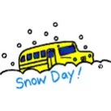Snow Day Activities - Primary 2
If school is closed due to poor weather conditions, please choose three activities to complete each day that you are not in school. Upload photos or recordings to SEESAW so that we can share them in class.
Technology/ICT  - Use your recycling to make a snow mobile that we can hang in the classroom.  - Draw a picture of a super sledge and label what it can do.  - Design a winter home for an animal. Draw and label it.  - Complete some activities and games on the following websites… www.topmarks.co.uk  www.funbrain.com www.bbc.co.uk/schools | Literacy  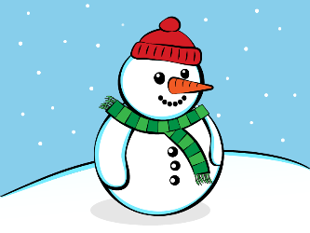  - Write a story about a snowman you have made, include information about what happened first, next and finally. Or write a set of instructions on how to build a snowman.  - Create a new ending for a story you have read.  - Make a new Talking Shoebox about what you did on your snow days.
Other  - Using a song of your choice create an exercise routine that will warm up all your muscles. Share your routine with your friends.  - Create a giant picture in the snow. This might involve sculpting the snow or clearing snow away.  - Fill 2 containers with snow. Cover one with something like a towel etc. Which one do you think will melt the quickest? Check your snow after a while and which one melted first. | Numeracy  - Draw pictures or record in your jotter what you did at different hours of the day. Can you write o’clock or half past time- example: 9 o’clock eating breakfast, 10.30am playing in the snow.  - Get an adult to give you a number. Make as many number stories as you can. For example 12… (6 + 6, 10 + 2, 14 – 2 etc.). Can you use a bigger number each day?  - Make some patterns in the snow and draw them.  - Build a snowman and measure how tall it is.  - Log onto Sumdog and see how well you can do. www.sumdog.com

